
Code:
117672E
Update: 14.04.2024
Worker safety instructions
according to §14 GefStoffV

Advice: The samples for risk assessments (Section 6 Hazardous Substance Ordinance/§ 6 GefahrstoffV0) and operating instructions (Section 14 Hazardous Substance Ordinance)/ § 14 GefahrstoffV0) have been created to the best of our knowledge and with the greatest possible care. Ecolab only creates operating instructions for its products on customer request. The operating instructions are based exclusively on the information in the safety data sheet of the product and Ecolab does not guarantee the correctness of the operating instructions for the specific application due to the lack of insight into the individual areas of application of the respective customer. In this respect, our samples can only serve as reference or example for your company. They do not discharge the employer from his responsibility referring to §§ 6 and 14 of the Hazardous Substances Ordinance/§§ 6 and 14 Gefahrstoff-Verordnung and must therefore be adapted by the customer to the local conditions and requirements related to the workplace obligatory. We ask for your understanding that Ecolab cannot be held responsible or accept any liability particularly with regard to the completeness, correctness and applicability of the samples provided.
Company: |  |  |  |  |  | Responsible physician or clinic:
Division: |  |  |  |  |  | Emergency telephone contact:
Position / Function: |  |  |  |  |  | First aid person:
Hazardous Materials Name
SOLUSCOPE P
UFI: 7K4F-NMV2-WF00-GVN6
Instrument Disinfectant - For professional users only.

Hazardous components which must be listed on the label:
Hydrogen peroxide
,
Acetic acid
,
Peracetic acid
,
Components: Oxygen-based bleaching agents,
The following information refer to the handling of undiluted product
Hazards Identification
 | 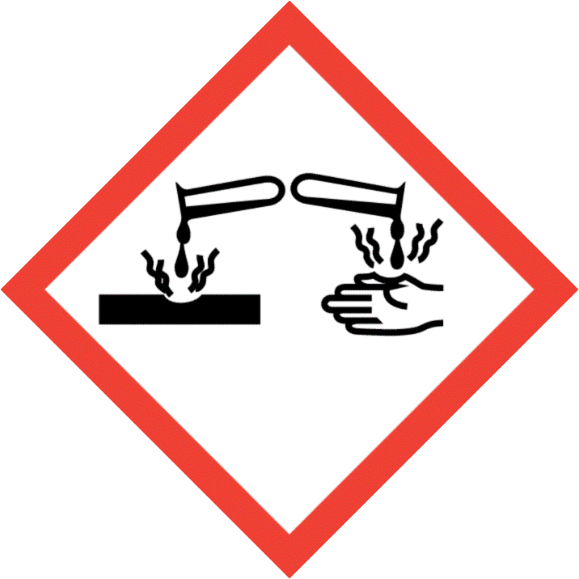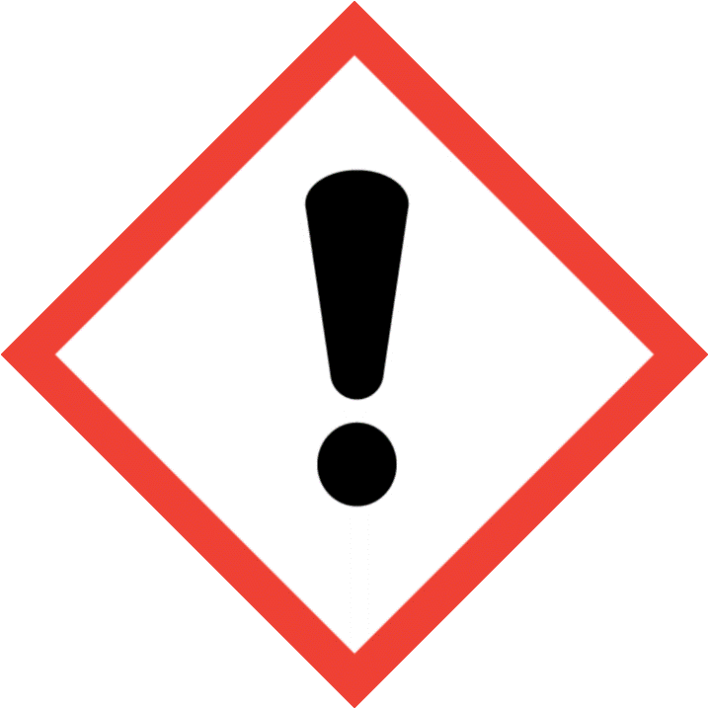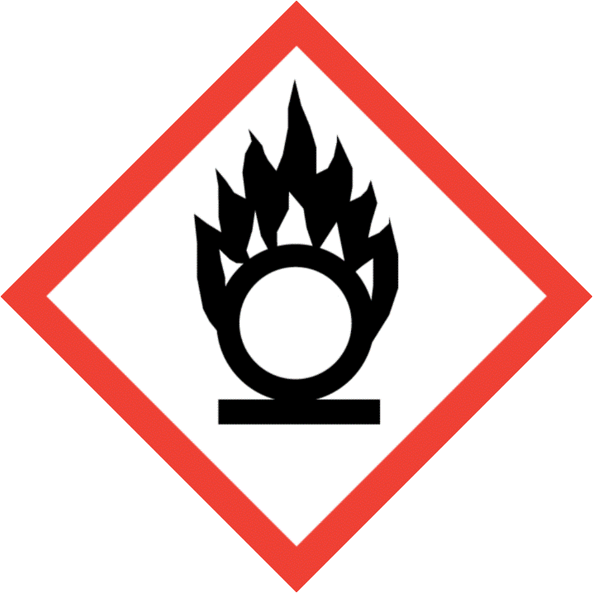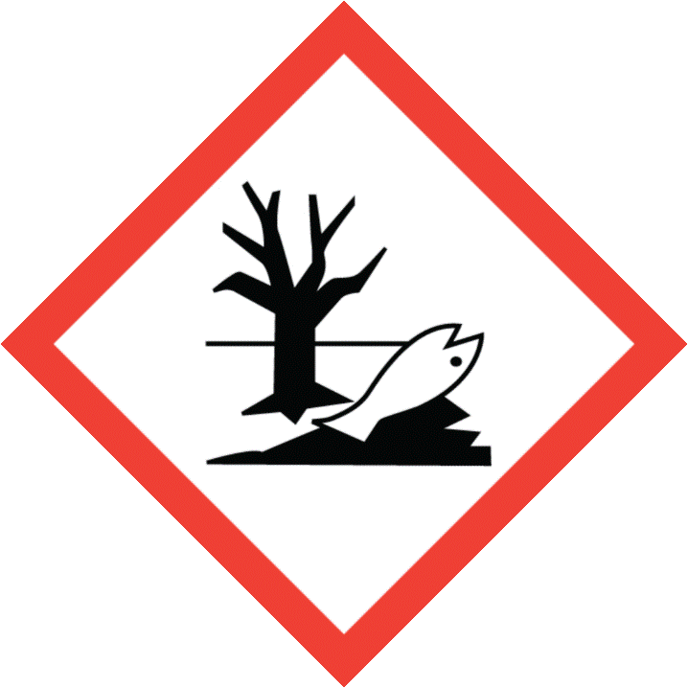
Signal Word |  |  |  | Danger
Hazard Statements |  |  |  | H272 May intensify fire; oxidiser.  H290 May be corrosive to metals.  H302 + H332 Harmful if swallowed or if inhaled.  H314 Causes severe skin burns and eye damage.  H410 Very toxic to aquatic life with long lasting effects.
Supplemental Hazard Statements |  |  |  | EUH071 Corrosive to the respiratory tract.
Hazard class for water |  |  |  | WGK 2
Protection measures and instructions
     |  |  | Do not ingest.  Do not get in eyes, on skin, or on clothing.  Use only with adequate ventilation.  Wash hands thoroughly after handling.  Do not breathe spray, vapour.  Do not mix with bleach or other chlorinated products – will cause chlorine gas.  In case of mechanical malfunction, or if in contact with unknown dilution of product, wear full Personal Protective Equipment (PPE).
 |  |  | Eye/face protection: Safety goggles, Face-shield
 |  |  | Hand protection: In case of skin contact it is recommended to wear gloves to avoid oxidation effect (e.g. skin whitening), Recommended preventive skin protection, Gloves, Nitrile rubber, butyl-rubber, Breakthrough time: 1 – 4 hours, Minimum thickness for butyl-rubber 0.7 mm for nitrile rubber 0.4 mm or equivalent (please refer to the gloves manufacturer/distributor for advise)., Gloves should be discarded and replaced if there is any indication of degradation or chemical breakthrough.
 |  |  | Skin and body protection: Personal protective equipment comprising: suitable protective gloves, safety goggles and protective clothing including appropriate safety shoes
 |  |  | Respiratory protection: When respiratory risks cannot be avoided or sufficiently limited by technical means of collective protection or by measures, methods or procedures of work organization, consider the use of certified respiratory protection equipment meeting EU requirements (89/656/EEC, (EU) 2016/425), or equivalent, with filter type: Combined particulates and inorganic gas/vapour type
Behaviour in danger situations
Suitable extinguishing media: Water
Unsuitable extinguishing media: Foam, Carbon dioxide (CO2), Dry chemical
Stop leak if safe to do so., Isolate the waste do not allow it to come into contact with incompatible materials. For small spills contain with sand or vermiculite and dilute the contained product at least 10 times with water. Transfer to an open topped container and remove to a safe place for neutralization* / disposal. For large spills contain spill and evacuate the area, leave until the reaction subsides, then collect up for disposal. Obtain consent from the local water company / authority if considering discharge to sewer. *NEUTRALIZATION : once diluted, neutralize with a suitable alkali such as sodium bicarbonate., Combustible materials exposed to this product should be rinsed immediately with large amounts of water to ensure that all product is removed., Residual product which is allowed to dry on organic materials such as rags, cloths, paper, fabrics, cotton, leather, wood, or other combustibles may spontaneously ignite and result in a fire.
First aid
In case of eye contact: Rinse immediately with plenty of water, also under the eyelids, for at least 15 minutes. Remove contact lenses, if present and easy to do. Continue rinsing. Get medical attention immediately.
In case of skin contact: Wash off immediately with plenty of water for at least 15 minutes. Wash clothing before reuse. Thoroughly clean shoes before reuse. Get medical attention immediately.
If swallowed: Rinse mouth with water. Do NOT induce vomiting. Never give anything by mouth to an unconscious person. Get medical attention immediately.
If inhaledRemove to fresh air. Treat symptomatically. Get medical attention.
Waste treatment
 |  | Dispose of in accordance with the European Directives on waste and hazardous waste. Waste codes should be assigned by the user, preferably in discussion with the waste disposal authorities.
Date: |  |  |  |  | Signing manager:

